# **Investigation on Job Opportunity**

I am currently on my second year in bachelors. I have always dreamt of becoming a successful programmer. I got the chance to do projects on programming, before. I got to work on Web Development, GUI, database, and many more. Recently, I was able to work on a group project called ‘Drone surveillance’, where I mainly overlooked the development part. During the project, I got to learn about different tools and technologies, such as OpenCV, TensorFlow, DJI Tello drone, and many more. I got to know about face recognition and image processing. Therefore, I believe the knowledge and skills I got to learn while doing these projects, makes me eligible to apply on jobs, such as web developer, python developer, java developer, front-end developer, back-end developer, full stack developer, software engineer and many other. Some companies, that had the job opportunities I was looking, for are mentioned below.

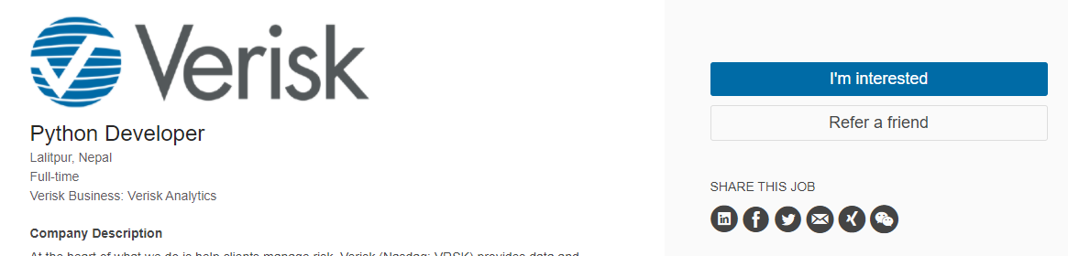

Figure : Versirk python developer

Verisk Nepal is a software developing and IT(Information Technology) company in Nepal. This IT company was launched in 2009. It provides clients business support, User interface designs. Deerwalk is an IT company. It was established in 2010. They have more than 300 employees worldwide. They are known for their loyalty with their clients, so they are quite a respectable company.

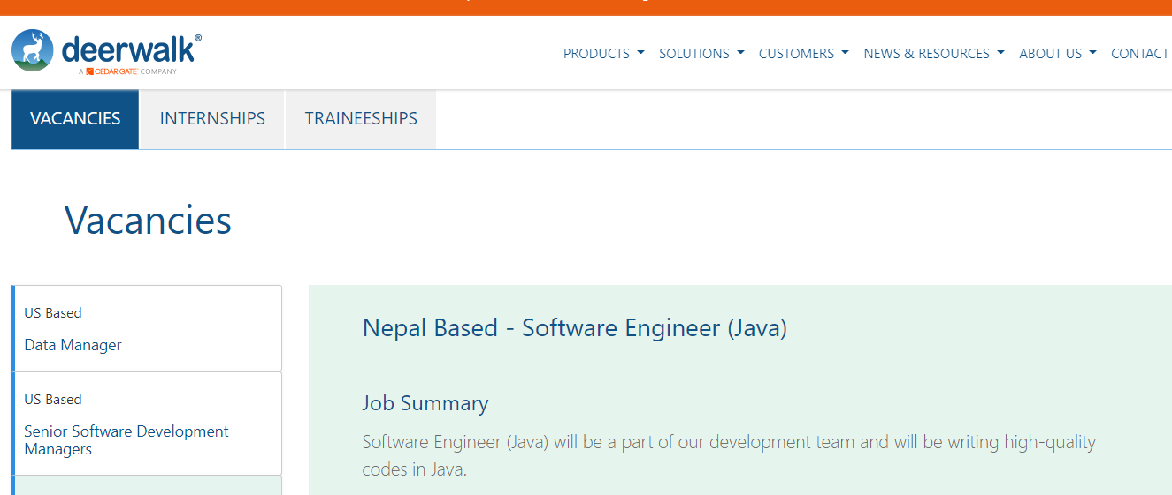

Figure : Deerwalk software engineer

Deerwalk is a software company that was founded in 2010. It is a population health management, data management, and healthcare analytics company, with over 300 employees worldwide. They are a Lexington based software company. (*Deerwalk* n.d.)

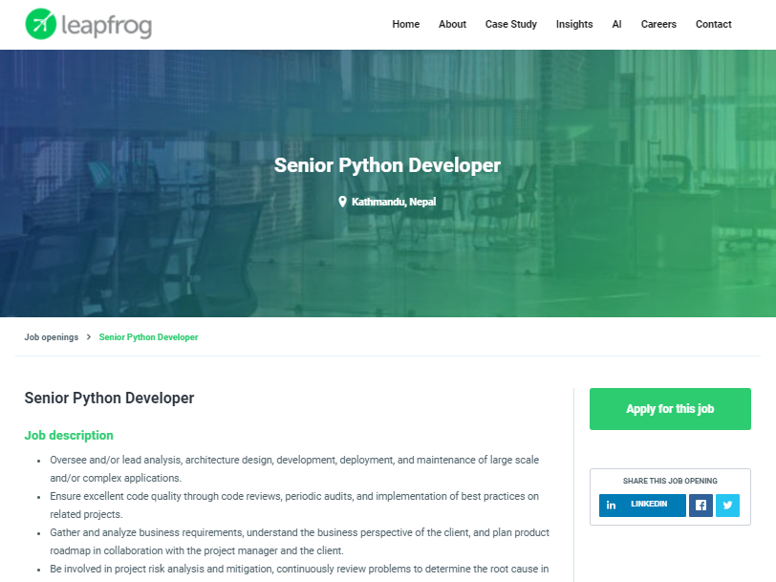

Figure : Leapfrog senior python developer

Leapfrog was established in 2010, which is a well-known company in Nepal. They help clients with business, software development and with other services. They have run this company for more than 10 years now with more than 200 projects and more than 100 happy customers. Their mission statement is: “Our mission is to enable people anywhere to solve big problems. Our customers choose us because we help innovate and adapt faster with world-class engineers and product engineering practices” and their vision statement is, “Our vision is to enable the world’s most important ideas to make immediate impact”. (*About Us | Leapfrog Technology* n.d.)

The values of leapfrog are :-

1. Be Remarkable
2. Always Be Learning
3. Be Nice
4. Openness
5. Honesty
6. Customer Focus

The requirement for this job is to have knowledge about python frameworks such as Django, and databases like MySQL, which lines up with my expertise perfectly, as I have worked with these in the past to create a website. In order to apply for this job, we can simply go to the website of the leapfrog and apply. We need our CV and also we need to answer certain questions related to our experience and expertise. In most companies the process of hiring is, firstly they ask for resume then, there might be a written examination. Lastly, they’ll call us for an interview.

I believe that with my knowledge and experience in python’s frameworks such as Django and databases such as MySQL, I am qualified to be a candidate for this job. Also, this job will help me increase my knowledge of programming, web development specifically, and also helps me improve my other skills such as time management skills, communication skills and team management skills. Getting to work on a huge company as such, I believe I can get to learn from more experienced and knowledgeable personnel than myself.

Summarizing, all three companies are best in their own ways, but I think a job at leapfrog would be the best suited for me, as the requirements match perfectly with my expertise, and it can also help me increase my knowledge hugely.

**References**

* *Deerwalk* (n.d.) available from <<https://www.deerwalk.com/our-story>> [2 March 2021]
* *About Us | Leapfrog Technology* (n.d.) available from <<https://www.lftechnology.com/about-us/>> [6 March 2021]